**SaaS Provisioning Service to develop Multitenant application on SAP Cloud Platform, Cloud Foundry Environment**

* Multitenancy allows an application provider to serve applications and services to multiple tenants – a set of users. End users of the application access it through a URL dedicated to that tenant.
* A tenant-aware application has the capability to separate data securely per tenant, can share resources across the tenants, and can serve features from a single code repository.

**Pre-requisites:**

* SAP BTP cloud platform access
* Two sub accounts (Provider, Tenant)
* Create dev space with all small letters and without any special characters
* Business Application Studio
* Yeoman Generator need to be installed in BAS.

**Yeoman Generator Setup in BAS:**

**go to -> view section on BAS-> explore and install generators -> saphanaacademy**

* Run below command in BAS terminal

npm i -g generator-saphanaacademy-saas

npm i generator-saphanaacademy-mta

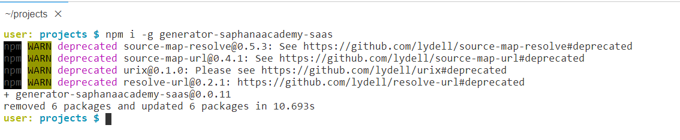

**Create Multi-tenant application:**

* Run command **“yo”** in terminal
* Choose “Saphanaacademy Saas” option

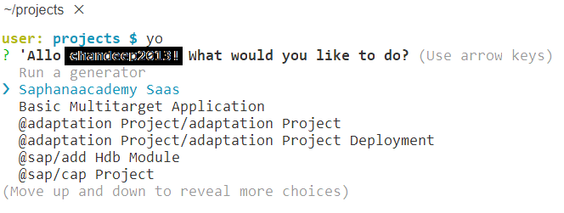

* Choose the required options from terminal

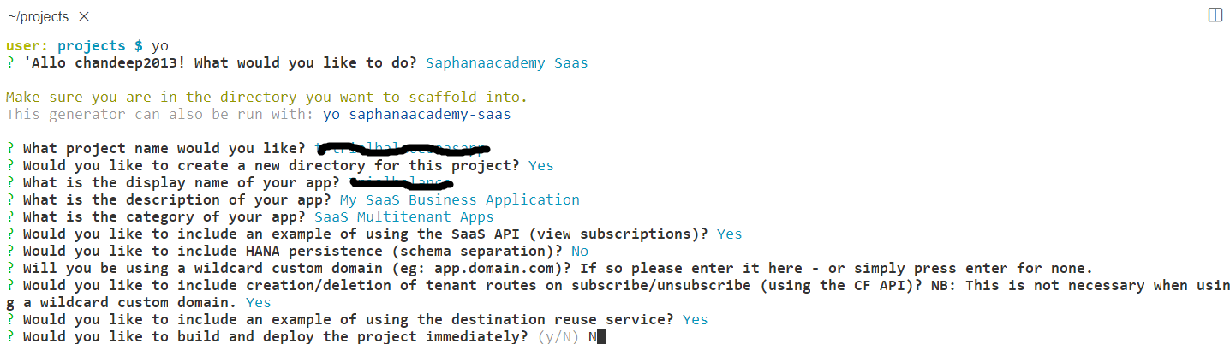

**Note:** Project Name and Space Name should not contain any underscore (_) symbol. We can use hyphen (-) symbol. Small letters are recommended.

* Folder structure will be generated once you choose all the required options from terminal.

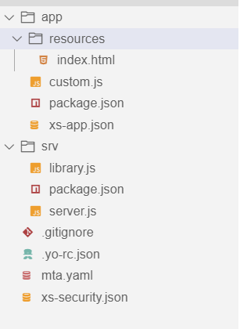

* Db folder is not generated Since I did not selected Hana persistency from terminal options.

**Build and Deploy Simple Application:**

* Right click on mta.yml file and choose to build mta.
* It will generate mta.archieves folder. Right click deploy mta.archieves file.

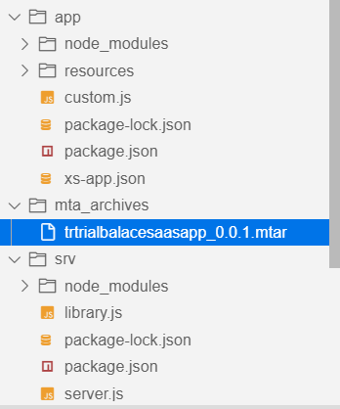

* Once deployed then we see the services in subaccount dev space.

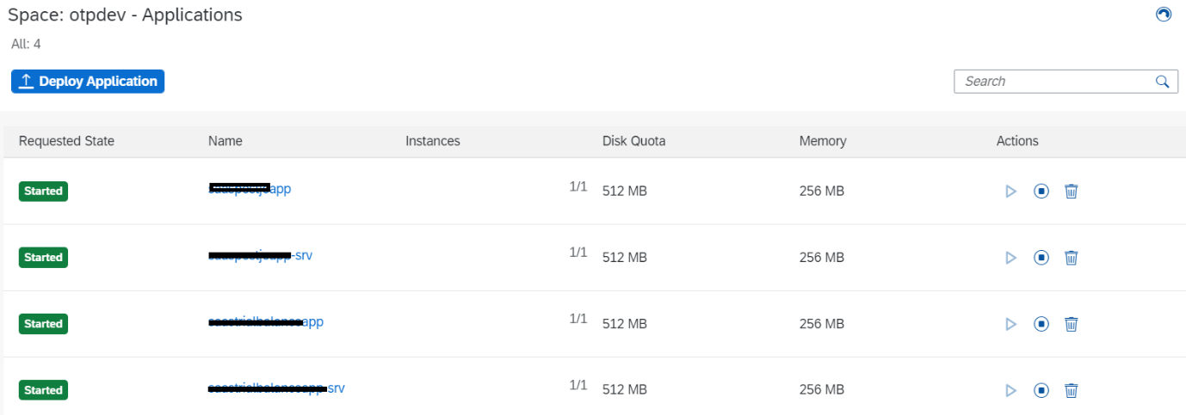

* SaaS applications we can find from service marketplace.
* Before deploying we need to do below steps.

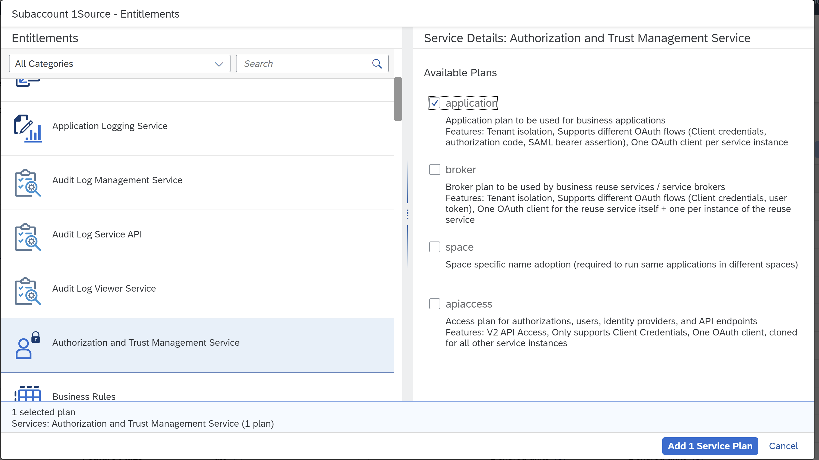

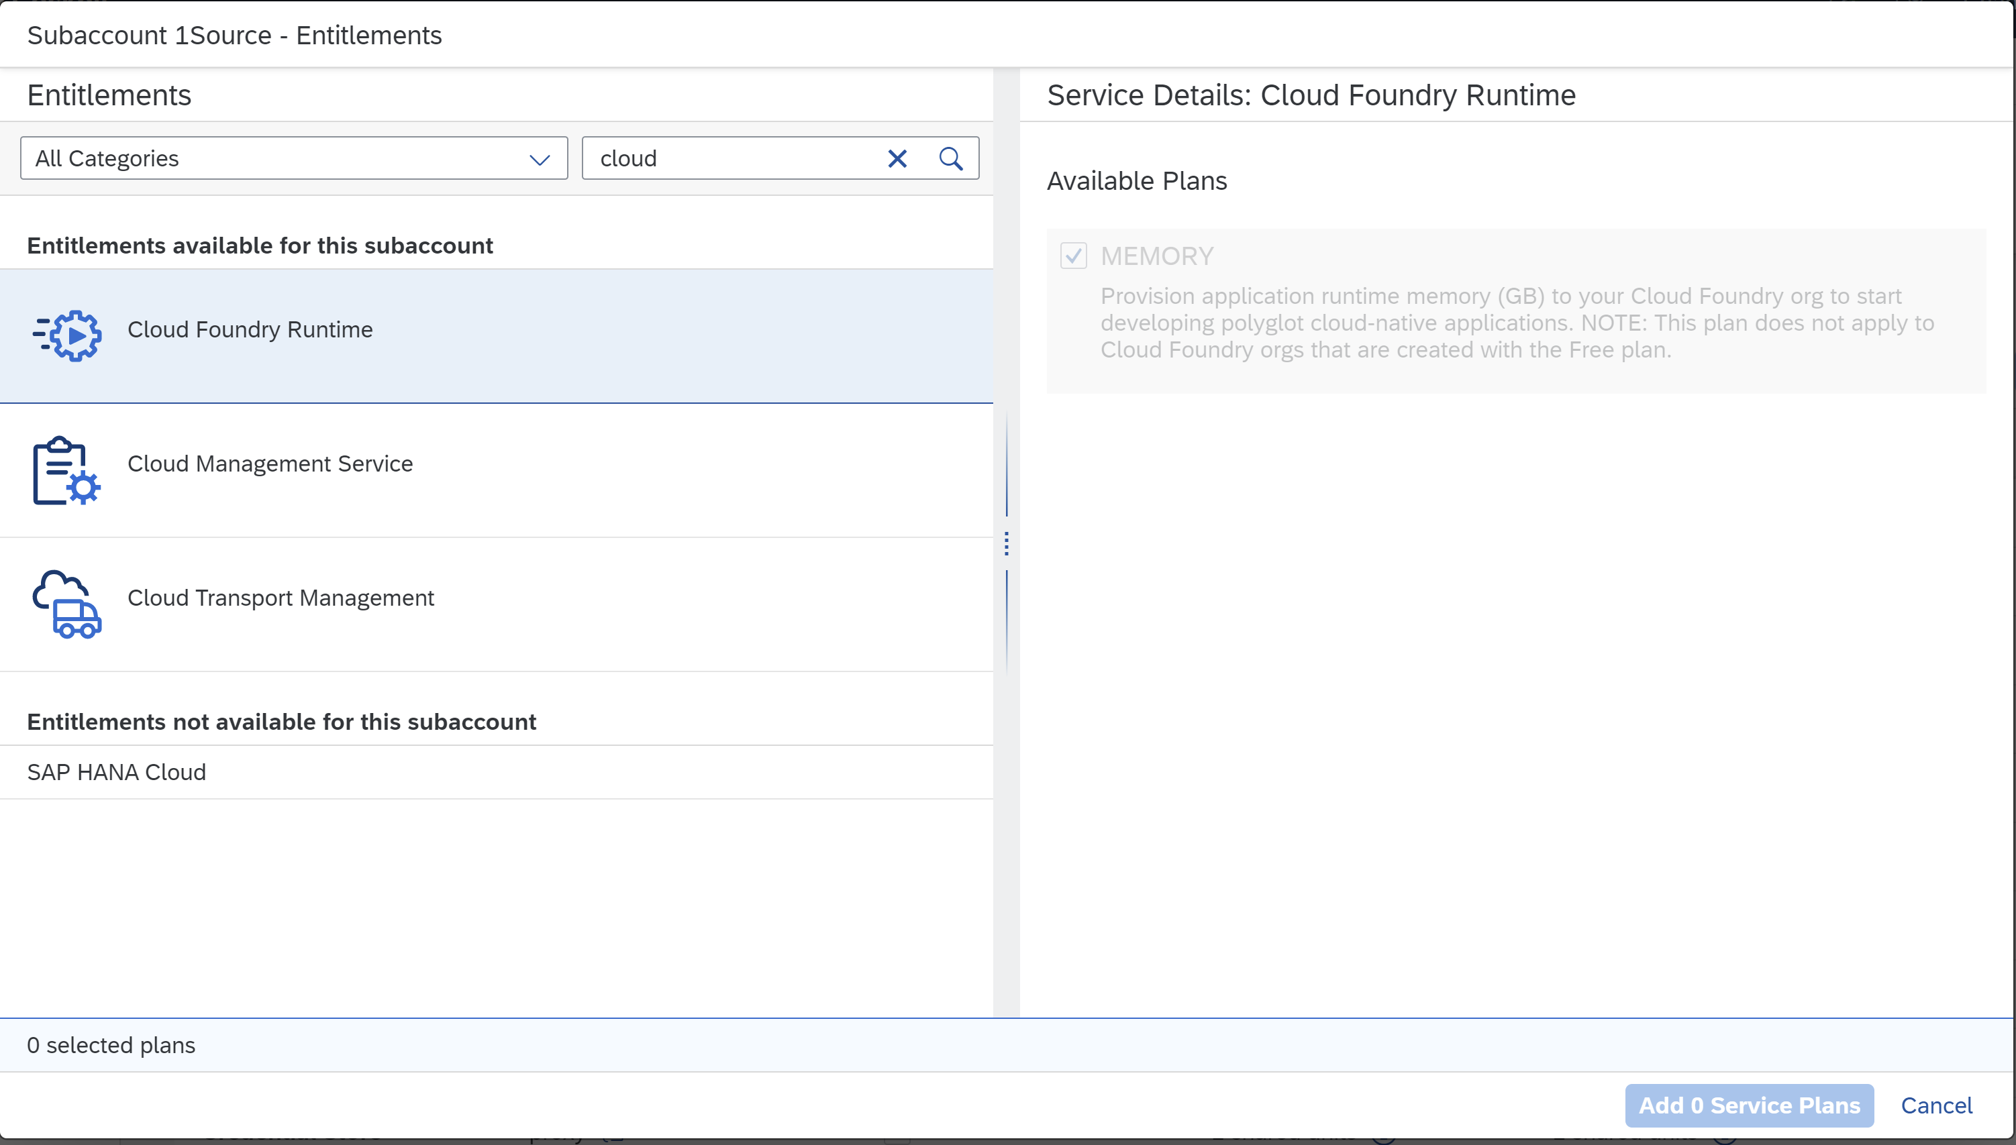

**xsuaa Authentication:**

[**https://developers.sap.com/tutorials/cp-cf-security-xsuaa-multi-tenant.html**](https://developers.sap.com/tutorials/cp-cf-security-xsuaa-multi-tenant.html)

[**https://blogs.sap.com/2017/11/16/guide-for-user-authentication-and-authorization-in-sap-cloud-platform/**](https://blogs.sap.com/2017/11/16/guide-for-user-authentication-and-authorization-in-sap-cloud-platform/)

**undepoy:** cf undeploy app --delete-services -f